**seeking, atop, stunning, circle, springs,**

Iceland, the island of fire and ice, has become one of the [world's top travel destinations](https://www.planetware.com/world/top-places-to-visit-in-the-world-us-az-234.htm), not only for thrill-seeking……………………. adventurers but also for nature lovers looking for something different.

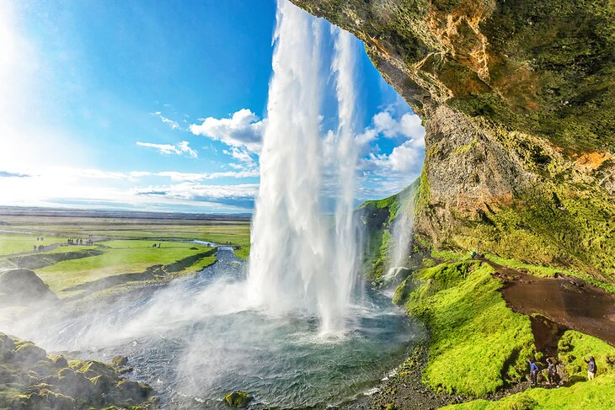

Seljalandsfoss waterfall in Iceland

Here, you'll discover active volcanoes, geysers, hot …springs…………….., glaciers, ice fields, and fjords, for this sparsely populated country, resting at the edge of the Arctic Circle, sits …atop………………… one of the world's most volcanically active areas.

One way to explore Iceland is on your own with a rental car, from several days to a week, including [a trip along the Ring Road](https://www.planetware.com/iceland/iceland-road-trip-driving-the-ring-road-isl-1-14.htm) that runs in a complete …circle………………. around the country.

Another way to plot your adventure in Iceland is with tours that can take you to the best options to see the northern lights; ATV trekking; and on day trips from Reykjavik to see some of Iceland's most …stunning………………….natural beauty, like the **Blue Lagoon** and waterfalls.

Find out more about the best places to visit with our list of the top attractions and things to do in Iceland.

**1. Explore Reykjavik by Foot**

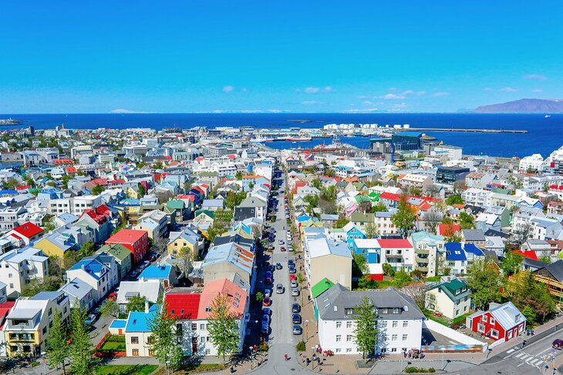Colorful houses in Reykjavik

**walkable, nibble, nearby**

The best way to start your trip to Iceland is by [sightseeing in the capital city of Reykjavik](https://www.planetware.com/iceland/top-rated-tourist-attractions-things-to-do-in-reykjavik-isl-1-2.htm). This is a …walkable……………………. city with many museums, restaurants, attractions, public art, and entertainment.

Take a stroll to see some of the iconic locations in the city, like Hallgrimskirkja church and the Sun Voyager sculpture, or relax in one of Reykjavik's 17 thermal pools. You will enjoy walking up and down the city streets and perhaps stop into one of the many artsy and boutique shops to buy a wool sweater or lava pottery.

You can also book a [Reykjavik Food Walk Tour](https://www.viator.com/tours/Reykjavik/Reykjavik-Food-Walk/d905-116425P1?eap=planetware-tours-14254&aid=vba14254en) and …nibble……………….. your way through Reykjavik's food scene enjoying local cheeses, or try an authentic Icelandic hot dog.

Some of the [best resorts in Iceland](https://www.planetware.com/iceland/top-rated-resorts-in-iceland-isl-1-12.htm) are in Reykjavik, so you can base yourself in the city and take day trips. An extremely popular way to visit …nearby………………. areas is on a [South Coast Full Day Tour by Minibus from Reykjavik](https://www.viator.com/tours/Reykjavik/Your-South-Coast-Full-Day-Tour-by-minibus/d905-36855P2?eap=planetware-tours-14254&aid=vba14254en).

**2. Ride to the Top of Hallgrímskirkja**

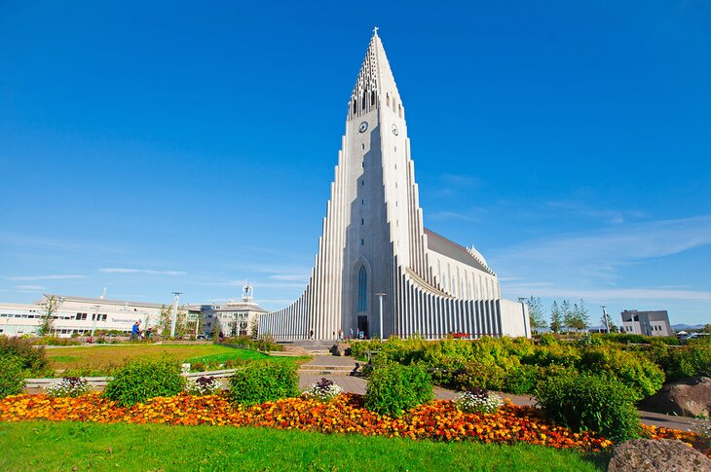Hallgrímskirkja

**recognizable, striking, panoramic, spectacular, wonders,**

A Reykjavik modernist icon, this visually …spectacular……………….. church is one of the city's top attractions, and when you see it, you'll understand why. [Hallgrimskirkja](https://www.hallgrimskirkja.is/en) is **the tallest and most …recognizable…………………….building in the country**.

The Black Falls (a basalt rock formation), which is one of Iceland's natural …wonders…………….inspired the architectural design. A climb to the top of the 73-meter-high tower is particularly rewarding. Here, you'll be treated to …striking……………………….. views across the city and surrounding landscape.  
  
At the front of the church is a statue of Icelander Leifur Eiriksson ("Leif the Lucky"), the first European to discover America around 1,000 CE. It seems he beat Christopher Columbus by around 500 years or so. For a small fee, you can take the elevator to the top and get the best…panoramic………………….. view of Reykjavik.

Address: Hallgrímstorg 1 101, Reykjavik

**3. Soak in the Blue Lagoon, Grindavík**

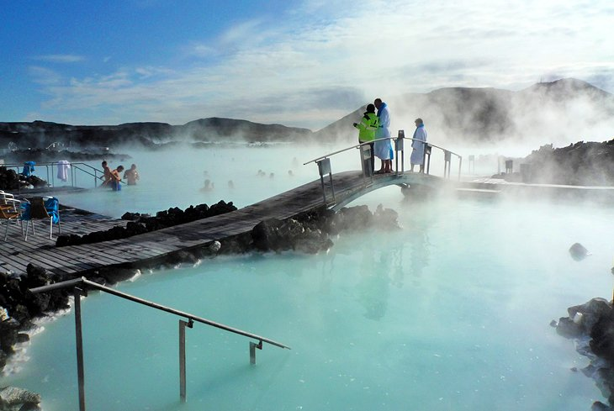

Blue Lagoon, Grindavík

**bathing, treatments, tubs, setting,**

Just 40 minutes' drive from Reykjavík, the [Blue Lagoon](http://www.bluelagoon.com/), the most iconic of geothermal spas, is a must-see tourist attraction. Here, you'll find natural …bathing………………. in pale blue water in the shadow of a power station.

An entire Blue Lagoon industry has grown around this attraction since it first became a hit with locals in 1976. The water from the underground hot springs reaches 37-39 degrees Celsius and is said to be highly beneficial for both health and skin.  
  
If the die-hard Icelanders are anything to go by, don't knock the theory. Aside from bathing in a tubs …setting………………, there's a shop selling skincare products, a range of spa …treatments……………………, and places to eat and drink. Don't visit Iceland without coming here.

Rub on a mask of natural mud in minerals from one of the …tubs…………….. located on the edges of the lagoon. For the ultimate relaxing visit, you can stay at one of the two hotels at the Blue Lagoon and add on a day at the Retreat Spa.

It is easy to book a bus trip to the Blue Lagoon from Reykjavik, but if you want to add an extra element of Iceland adventure, you can book a day trip on an ATV that will have you drive there over lava rock paths and take you back by coach to your hotel.

Address: Norðurljósavegur 9, 240 Grindavík

**4. Gullfoss Waterfall**

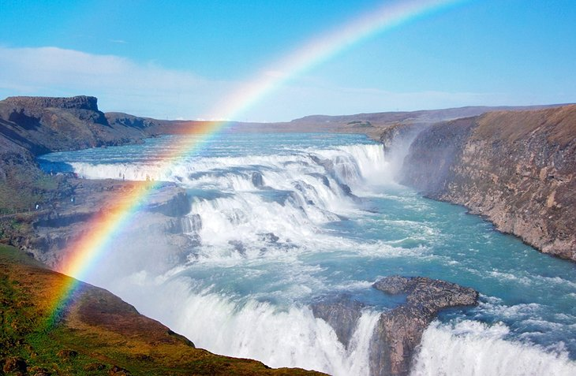

Gullfoss Waterfall

**magnificent, astonishing, spine-tingling, encompasses,**

…Magnigicent………………….. Gullfoss Waterfall lies around 90 minutes west of Reykjavik and is one of the [best waterfalls in Iceland](https://www.planetware.com/iceland/top-rated-waterfalls-in-iceland-isl-1-16.htm). The river Hvítá plummets into a canyon, which forms three-step terraces, creating a powerful torrent. Gullfoss …encompasses…………………….two cascades; the upper one drops 11 meters, while the lower one cascades about 21 meters.

Torrents of water flow over Gullfoss at an average rate of 109 cubic meters per second, although heavy floods have recorded an …astonishing……………………. rate of nearly twenty times that. A word of warning: there are no rails or barriers, just a …spine-tingling…………………. spectacle to enjoy amid surroundings as nature intended.

**5. Spot Whales out of Reykjavik**

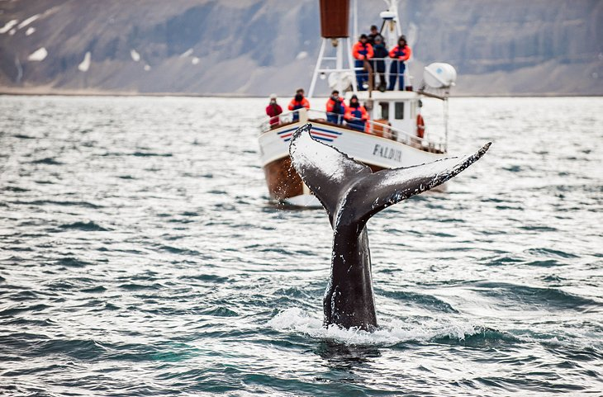Whale Watching, Reykjavik

**ringside, depart, awe-inspiring,**

No matter what [time of year you plan to travel to Iceland](https://www.planetware.com/iceland/best-time-to-visit-iceland-isl-1-13.htm), whale watching happens year-round, although summer is the most popular time to see these gentle giants. During the warmer months, trips run day and night, including whale watching in the midnight sun.

Tour operators say there's an 80-95 percent chance of seeing these magnificent creatures, depending on the time of year. Best of all, surfacing often happens right near the boats, so you may well enjoy a …ringside………………….. seat for one of nature's most …awe-inspiring………………….. spectacles.

Other ocean-going tours are also available, such as bird-watching and island visits. Tours are convenient since there are several types available, and they …depart……………………. from Reykjavik's Old Harbor. Stop for a dinner of fresh cod after you return in one of the many small, rustic restaurants located in the harbor area.

Address: Ægisgardur 5, Reykjavik's Old Harbor

**6. Watch Spectacular Geysers**

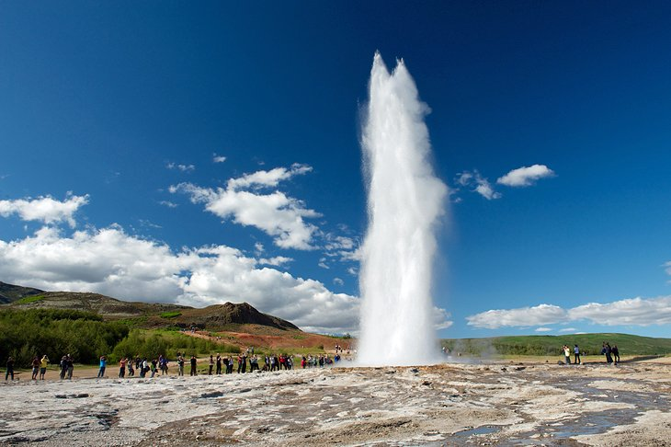Strokkur

**spring, pits, geyser, shoots,**

An easy 50-minute drive from [Reykjavik](https://www.planetware.com/iceland/top-rated-tourist-attractions-things-to-do-in-reykjavik-isl-1-2.htm), **Strokkur Geysir** (after which all geysers are named) is the most popular fountain …geyser………………….. in the country and is famed throughout the world. This highly active hot …springs………………… area lies in the southwest of Iceland beside the Hvítá River and is a favorite stop along what's known as the **Golden Circle.**

Boiling mud …pits……………….and around 100 other smaller exploding geysers are waiting to be explored here. Every few minutes, **Strokkur** …shoots……………….. water 30 meters into the air. Visit the **Geysir Center** for exhibits and informative presentations year-round.

A memorable experience is digging up Geysir or "hot spring" bread, rye bread that has been baking underground for 24 hours. Visitors can also help a chef boil eggs in a hot spring to accompany the bread. One popular day tour to the area is the [Golden Circle Classic Day Trip from Reykjavik,](https://www.viator.com/tours/South-Iceland/Golden-Circle-Classic-Day-Trip-from-Reykjavik/d24828-2970AH12?eap=planetware-tours-14254&aid=vba14254en) which has several stops and can ensure you get the iconic geyser photo from your trip.

**7. Take in the Northern Lights, Aurora Borealis**

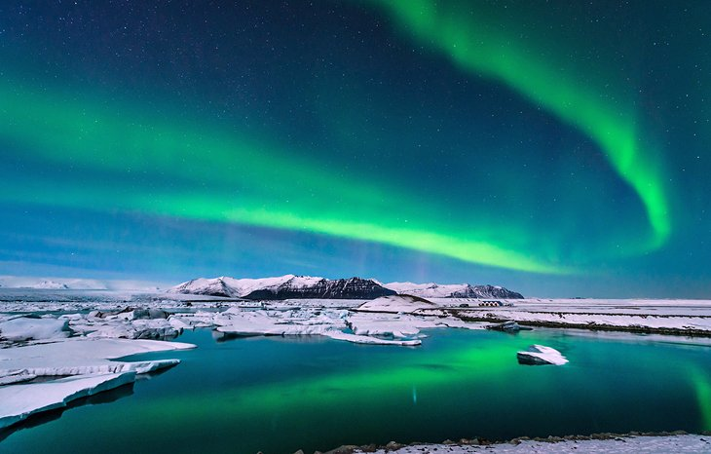The northern lights, Aurora Borealis

**radiating, bursts, remote, lodging,**

The northern lights, or Aurora Borealis, are among the most popular tourist attractions in Iceland. This is one of the [best places in the world to see the northern lights](https://www.planetware.com/world/best-places-to-see-the-northern-lights-cdn-1-234.htm).

Auroras are linked to solar wind, a flow of ions …radiating …………………. from the sun. These particles become ensnared in the earth's magnetic field and collide with atmospheric molecules, causing … bursts ………………. of energy, which appear as large circles around the poles. This spectacular natural light show is best admired in remote places and is particularly impressive at times of increased solar activity.  
  
Since the appearance of the northern lights is unpredictable, most hotels and …lodging………………….. operators can provide you with nightly predictions before you go to bed and add you to an overnight call list.

They will call your room if the lights appear, as they may only be visible for a short window of time. For one of the most optimal opportunities to experience the northern lights, you can take a tour like the [Northern Lights Night Tour from Reykjavik,](https://www.viator.com/tours/Reykjavik/Northern-Lights-Night-Tour-from-Reykjavik/d905-2970AH33?eap=planetware-tours-14254&aid=vba14254en) which takes you to the …remote………………… countryside for the best chance to see this natural wonder.

**8. Hike in Landmannalaugar Nature Reserve**

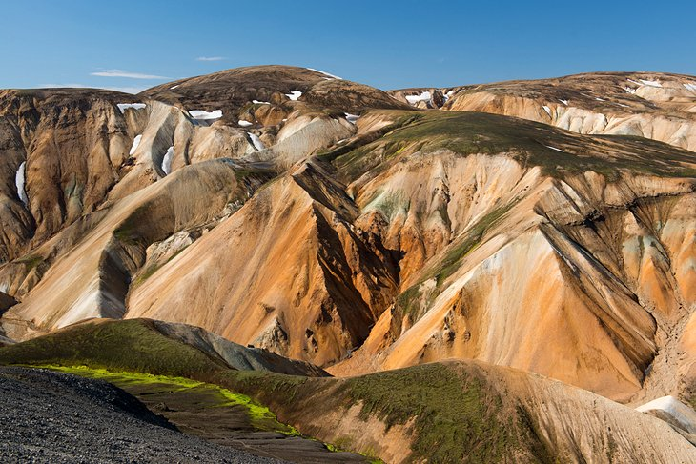Landmannalaugar

**hues, extensive, rugged,**

In the south of Iceland, 180 kilometers from Reykjavik, is Landmannalaugar National Park, one of Iceland's most popular tourist destinations. The main features of this mystical landscape are the multi-hues………………… rhyolite mountains, **Hekla volcano**, and …extensive……………… lava fields.

Hiking and horse riding are popular things to do here, and hikes range from a couple of hours to several days. You can visit from June to late September, after which the road is closed. A mountain lodge (**Landmannalaugar Hut**) with basic facilities accommodates 75 people. Expect raw nature, …rugged…………………. scenery, and utterly spectacular views.

**9. Maelifell Volcano & Myrdalsjökull Glacier Park**

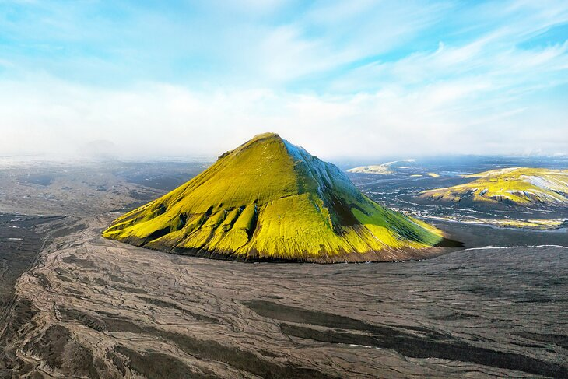Maelifell Volcano

**undisputed, glacial, surreal,**

South of Landmannalaugar lies Myrdalsjökull Glacier Park, which for safety reasons can only be visited during summer. Large amounts of rain soak the area, particularly in winter, when roads can be severely damaged. Maelifell volcano is the …undisputed……………………… jewel-in-the-crown of this wild, rugged …glacial……………….. landscape.

The perfect cone shape gives Maelifell the look of a classic volcano, however during the warm season, a lavish green covering of moss gives it a …surreal……………………, otherworldly appearance. The **park is full of volcanoes, hot springs**, and other remarkable sites. To the west of Myrdalsjökull is a smaller glacier, Eyjafjallajökull (Island Mountain Glacier). A popular and thrilling way to explore is by snowmobile.

**10. Attend a Concert at Harpa**

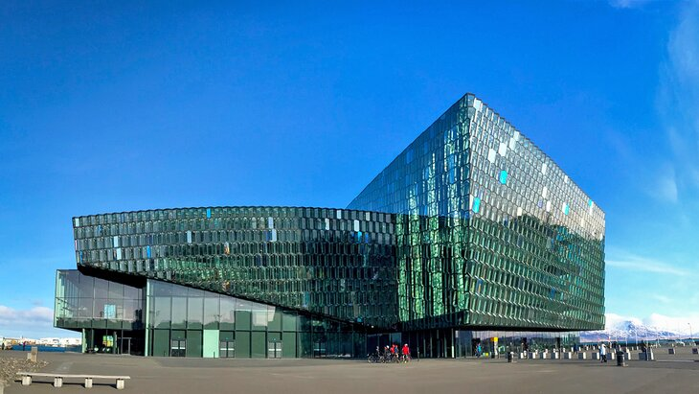Harpa concert hall in Reykjavik

**award-winning, array, emanating, pick up,**

As you plan your time in Iceland, set aside an evening for a concert at the magnificent [Harpa](https://www.harpa.is/en/whats-on), Reykjavik's premier concert hall. If time or performance schedules do not fit your schedule, plan to at least stop by to admire the …award-winning………………………. architecture of the building. Nighttime is one of the best times to see the …array……………….. of colorful lights …emanating………………….. from this honeycomb-shaped structure.

Harpa is a treasured landmark in Iceland, attracting international performances ranging from violinists and classical music to performing arts.

This venue makes for a great night out in the heart of the city. Enjoy dinner at one of Harpa's two restaurants and go for a stroll outside along the waterfront after the performance. The gift shop is a great place to …pick up………………….. unique souvenirs, many made by local artists.

Address: Austurbakki 2, 101 Reykjavik

**11. Explore the Skaftafell Ice Cave, Vatnajökull National Park**

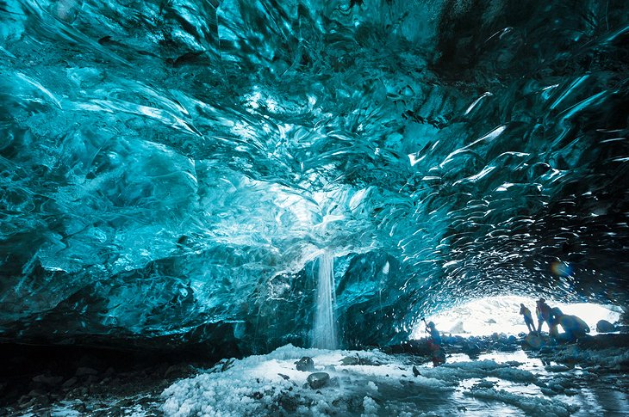Skaftafell Ice Cave, Vatnajökull National Park

**washed, off-season, cracks,**

In the south of the country, [Vatnajökull National Park](https://www.vatnajokulsthjodgardur.is/en) is a land of glaciers and magnificent ice caves that attracts adventurers from across the globe. This vast national park (one of three in Iceland) is divided into four sections and consists of **Vatnajökull glacier** and its surroundings.

You'll find a number of visitor centers; those in **Skaftafell Ice Cave** and Höfn are open year-round, while Skriðuklaustur and Jökulsárgljúfur are closed in winter. The best time to visit Skaftafell Ice Cave is during winter after heavy rain has …washed……………… the top layer of the glacier away.

If seen at the right time, the cave is bathed in spectacular blue light. Group visits to all areas can be arranged …off-season…………………. If you are in good shape, you might consider doing a glacial trek with an experienced guide. The treks get you on the ice for an unforgettable experience to see glacial …cracks……………………. and caves and even drink fresh water from small pools on the surface.

**12. Visit an Active Volcano at Askja Caldera**

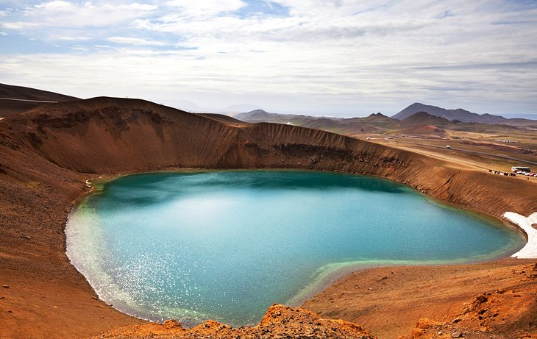Askja Caldera

geothermal, dip, eruption,

In the northern region of **Vatnajökull National Park,**the Askja caldera and the …geothermal………………………. pool in the **Dyngjufjöll Mountains** are not for the faint-hearted. However, if you'd like to say you've taken a …dip…………………. in a live volcano, then this is for you.

Askja is an impressive 50 square kilometers in size. The surrounding mountain range was formed during volcanic activity, and Askja was partly created by an …eruption…………………… of burning ash that collapsed the roof of the central volcano's magma chamber.

The water in **Viti**, the geothermal pool and volcanic crater, is generally around 30 degrees Celsius. A word of warning, the banks can be very slippery, particularly in wet weather.

**13. Feel the Spray of Dettifoss Waterfall**

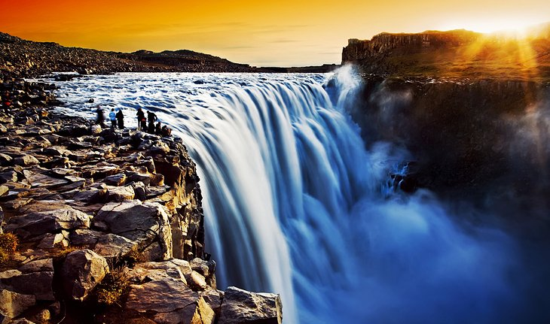Dettifoss Waterfall

**breathtaking, upstream,**

Dettifoss, in the north of **Vatnajökull National Park,** truly is a …breathtaking…………………… example of the raw power of nature. Plunging 45 meters and with a width of 100 meters, it's said to be the most powerful waterfall in Europe.

Generally, it's best to approach on the east side of the River Jökulsa, where the road is better. Along easy paths from Dettifoss, **Selfoss** is a smaller waterfall around one kilometer …upstream……………….. with a drop of around 10 meters. Below Dettifoss, the **Hafragilsfoss** waterfall tumbles 27 meters into a steep canyon. It's more advisable to drive than walk to Hafragilsfoss.

**14. Kirkjufell Mountain, Grundarfjördur**

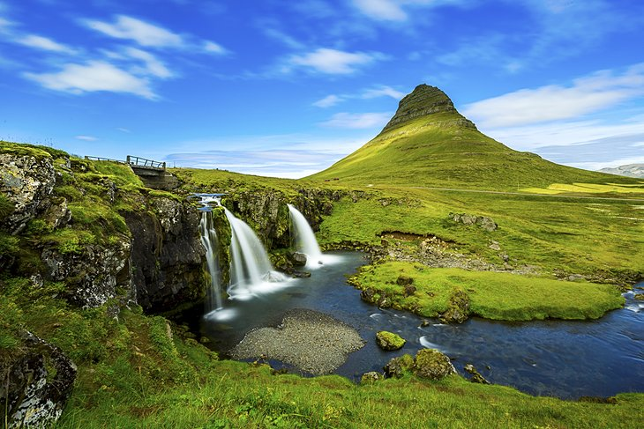Kirkjufell Mountain, Grundarfjördur

**looming, peninsula, awe-inspiring,**

Around 2.5 hours' drive northwest of Reykjavik is the small town of Grundarfjördur, a charming fishing village centrally located on the north coast of the **Snaefellsnes** peninsula. The town lies in a picturesque fjord, surrounded by mountains, with **Mt. Kirkjufell** …peninsula……………………. as a striking landmark.

Dotted about the surroundings, you'll discover small streams and waterfalls. During winter, Kirkjufell is a great place to watch the …looming………………………**northern lights**. **Eyrbyggja Heritage Centre** holds exhibitions on Grundarfjördur's seafaring history and is the information center for the whole peninsula.

**15. Float along a Glacial Lagoon**

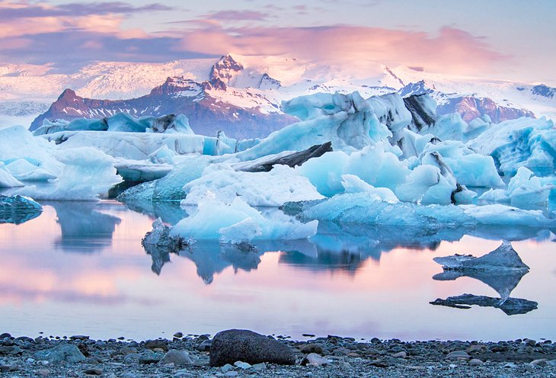Jökulsárlón Glacier Lagoon

**chunks, glacial, wonders, pebbles,**

While Iceland is full of natural …wonders…………………., one of the most spectacular is the Jökulsárlón Glacier Lagoon. You will ride in a boat through large …chunks………………… of ice that have separated from the glacier.

The floating ice in the lagoon ranges from the size of small …pebbles………………… to the size of cars, but since you are floating in the lagoon with them, they are close enough to touch. Witness the blue hue of …glacial………………….. cave formations and birds flying above in this natural environment.

The [South Coast and Jökulsárlón Glacier Lagoon Day Tour from Reykjavik](https://www.viator.com/tours/East-Iceland/Iceland-South-Coast-and-Jokulsarlon-Lagoon-Day-Trip-from-Reykjavik/d22630-2970AH35?eap=planetware-tours-14254&aid=vba14254en) is a popular tour for visitors who want to set up a home base for their visit to Reykjavik and do a day trip to this top attraction. The tour also includes visits to two beautiful waterfalls and spectacular views of mountains and glacial rivers along the south coast.

**16. Reynisfjara Black Sand Beach**

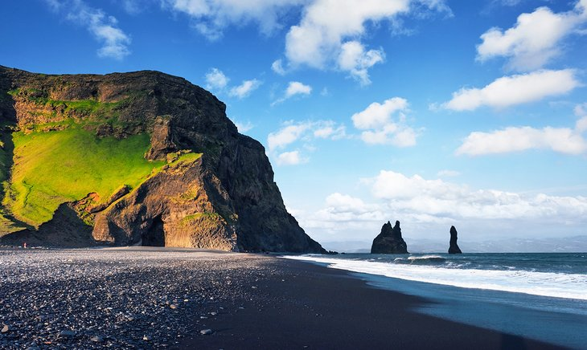Reynisfjara black-sand beach

**stacks, ferocious, allure,**

While Iceland has some stunning beaches, the Reynisfjara black-sand beach on the country's southern coast has an other-worldly appearance. This unique beach is known for its black sand and rocky sea …stacks…………………… that protrude from the oftentimes …ferocious……………………… waves coming in from the Atlantic Ocean.

The eerie yet stunning landscape of natural beauty at Reynisfjara beach is one of the reasons it was selected as a filming location for films like *Star Wars.* The lighting at this beach adds to its contrasting …allure……………………, which is why it is a must-visit for anyone who enjoys photography.

As with many natural locations in Iceland, Reynisfjara black-sand beach has dark folklore associated with it. Iceland legend says that the rocky basalt sea stacks were once trolls pulling seafaring ships to shore in the night, and they turned to stone during sunrise.

You are not likely to see any trolls during your visit, but you might see some of the thousands of seabirds, like puffins, guillemots, and fulmars, that nest in the columns.

The 2.5-hour drive to the beach is easy from Reykjavik, or you can take a guided trip along the southern coast that includes this as a stop if you want to spend more time at some of the other features on that side of the island.

**17. Tour the Raufarhólshellir Lava Tunnel**

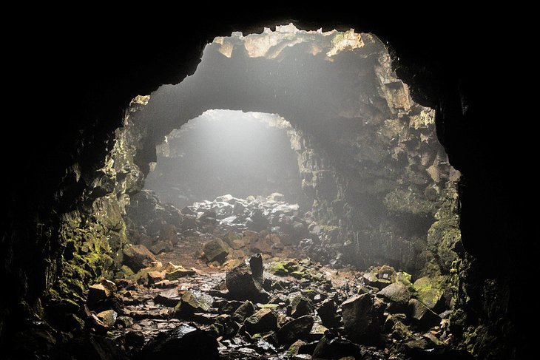Raufarhólshellir lava tunel

**hardened, crust, stunning, intriguing,**

The land of fire and ice has so many …stunning…………………. natural elements that visiting is an exciting science lesson into how volcanos work. One way to find out is by visiting the Raufarhólshellir lava tunnel in southwest Iceland.

At 4,461 feet, it is one of the longest lava tubes in the country. You can take a guided tour through the cave to get up close to the stunning lava rock formations and colorful walls that have formed below the earth.

A tour through the tunnel will walk you through the path where lava flowed during a volcanic eruption of the Bláfjöll Mountain Range more than 5,000 years ago. These tunnels were formed as flowing magma …hardened………………….. and thickened, creating a …crust……………………… roof resulting in a lava tube.

Outside the lava tube, you will see …intriguing…………………. green moss covering lava rock and craters formed from the eruption. It is only about a half hour from Reykjavik, and you can visit year-round. If you visit in the winter, plan on wearing extra layers and sturdy boots for icy and wet conditions.